Directions to the Church Street Research Unit at Yale University
Address: 2 Church Street South, New Haven, CT 06519
From 91 South (Bradley International Airport)
Follow I-91 South to Exit 1 (CT-34 W/Oak Street Connector). Stay right towards N Frontage Road/M.L.K Jr. Blvd. Turn left onto Church Street. Turn right onto Lafayette Street. The parking lot will be on your right.

From 95 North
Follow I-95 North to exit 47 for CT-34 W/Oak Street Connector towards New Haven/Downtown. Stay right towards N Frontage Road/M.L.K Jr. Blvd. Turn left onto Church Street. Turn right onto Lafayette Street. The parking lot will be on your right.

From 95 South
Take I-95 South to the I-95 North exit ramp. Follow I-95 North to exit 47 for CT-34 W/Oak Street Connector towards New Haven/Downtown. Stay right towards N Frontage Road/M.L.K Jr. Blvd. Turn left onto Church Street. Turn right onto Lafayette Street. The parking lot will be on your right.

From Route 8 South
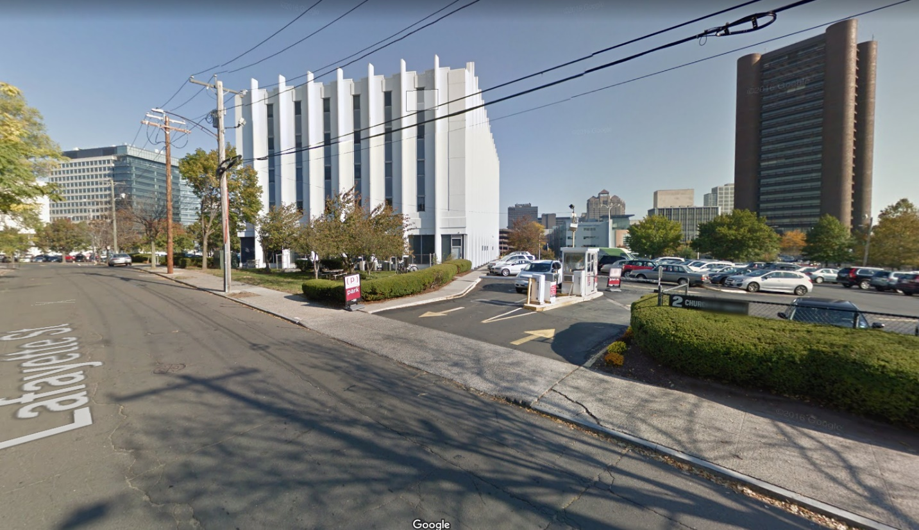
Follow Route 8 South to exit 15 for CT-34 towards Derby/New Haven. Turn right on CT-34 East. Turn right onto Derby Ave. Turn right onto Ella T Grasso Blvd. Turn left on Legion Ave. Continue onto S Frontage Road. Turn right onto Church Street S. Turn right at the first cross street onto Lafayette Street. The parking lot will be on your left.

